Alex Te

COEN 241

Fall 2021

Dr. Choi

Homework 3

Task1 Questions:

1. Output of “nodes” command:
   1. 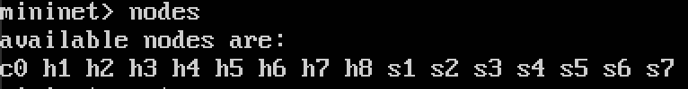
2. Output of “net” command:
   1. 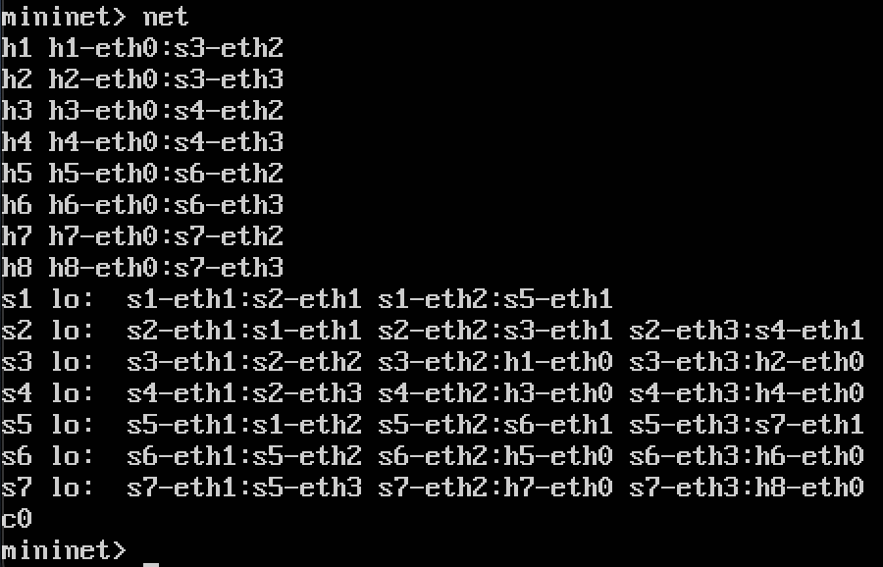
3. Output of “h7 ifconfig”
   1. 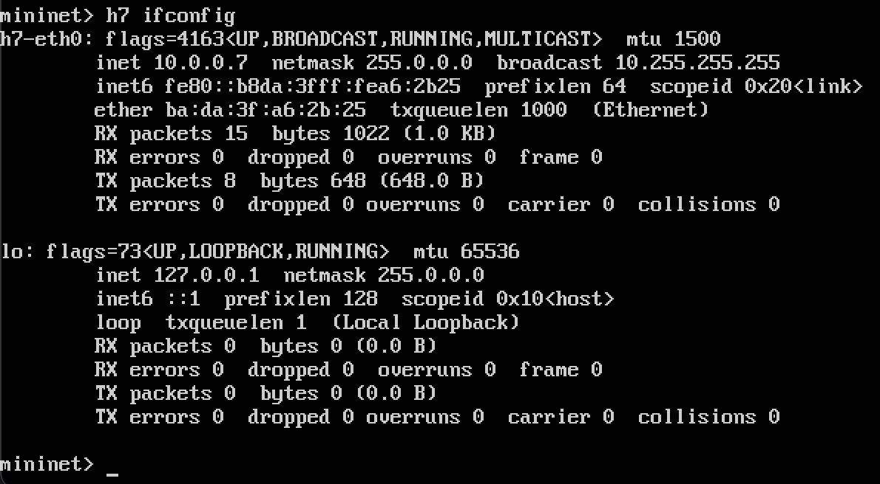

Task 2 Questions:

1. Draw the function of the graph . . .
   1. 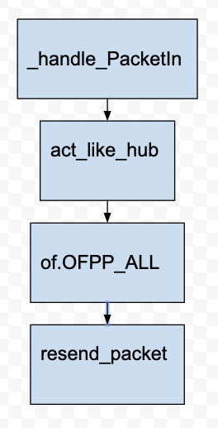
2. Have h1 ping h2 and h1 ping h8 for 100 times . . .
   1. How long does it take on average to ping for each case?
      1. The average ping for h1 to h2, over 100 samples was: 27.257ms
      2. The average ping for h1 to h8, over 100 samples was: 121.094ms
   2. What is the minimum and maximum ping you have observed?
      1. From h1 to h2, the minimum and maximum were: 18.963ms and 115.191 ms respectively.
      2. From h1 to h8, the minimum and maximum were: 101.054 ms and 257.528 ms respectively.
   3. What is the difference and why?
      1. The difference between the two pings was that h1 and h2 are connected to the same switch, so it takes only 2 hops to get h2. On the other hand, for h1 to h8, it requires 6 hops to get to h8.
3. Run “iperf h1 h2” and “iperf h1 h8”
   1. What is “iperf” used for?
      1. Iperf is used to monitor network performance and allows us to tune the network if needed.
   2. What is the throughput for each case?
      1. Throughput for iperf h1 h2: 157 Kbits/sec, 230 Kbits/sec
      2. Throughput for iperf h1 h8: 138 Kbits/sec, 338 Kbits/sec
   3. What is the difference, and explain the reasons for the differences.
      1. The difference between the two should be minimal since bandwidth should be the same throughout the network.
4. Which of the switches observe traffic? . . .
   1. The switches that observe traffic are switch 3, 2, 1, 5, 7. Switch 3 is used for both connecting h1 and h2 and h1 and h8. Switches 2, 1, 5, and 7 are used for communicating between h1 and h8

Task 3 Questions:

1. The code that we edited for act_like_switch works as a table. If the source packet is not in the mac_to_port table, it will need to add it so it “learns”. After reading the packet information, it determines whether or not the packet has been seen before. If is has, then it send it to its destination, if not, it is resent to everyone in the network that has been previously connected.
2. For the following, I was not able to have 1 host ping to the other host after starting task 3. When I closed out of pox and ran mininet without the --controller remote flag I was still having some issues with talking from h1 to h. However, for some weird reason after closing mininet 2 more times and rerunning it, I was able to ping h1 and h2 (without pox running). The following results will be pinging from h1 to s2 (host to switch). I saw on Piazza another student had the same comment for (Piazza @127).
   1. The average from h1 to s2, over 100 samples was: 0.459ms.
   2. The average from h1 to s7, over 100 samples was: 0.474ms.
3. Run iperf . . .
   1. Throughput did not respond for any cases because of the aforementioned issue.
   2. Cannot mention any changes because of the issue I ran into.